AI ASSISTED CODING
ASSIGNMENT-4.3
NAME:T.TEJASRI
HT NO:2303A51557
BATCH:09
Task 1: Zero-Shot Prompting – Leap Year Check
#Generate code for take user input and check wheather it is leap year are not
def is_leap_year(year):
if (year % 4 == 0 and year % 100 != 0) or (year % 400 == 0):
return True
else:
return False

year = int(input("Enter a year: "))
if is_leap_year(year):
print(f"{year} is a leap year.")
else:
print(f"{year} is not a leap year.")
OUTPUT:
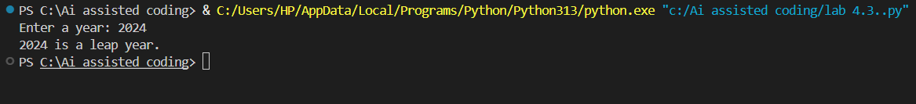
EXPLANATION: The program takes a year as input from the user.
The is_leap_year() function checks whether the given year follows leap year rules:
- It must be divisible by 4 and not divisible by 100, or
- It must be divisible by 400.
If the condition is true, the function returns True; otherwise, it returns False.
Based on the result, the program prints whether the year is a leap year or not.

Task 2: One-Shot Prompting – Centimeters to Inches Conversion
#generate code for taking user input and converting centimeters to inches use correct mathematical formula like example:1 cm = 0.393701 inches
def cm_to_inches(cm):
inches = cm * 0.393701
return inches
cm = float(input("Enter length in centimeters: "))
inches = cm_to_inches(cm)
print(f"Length in inches: {inches}")
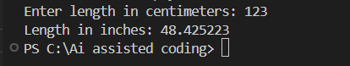
EXPLANATION:
The program asks the user to enter a length in centimeters.
The cm_to_inches() function converts centimeters into inches using the formula:
inches = cm × 0.393701
The converted value is returned from the function.
The final result is displayed to the user in inches.
Task 3: Few-Shot Prompting – Name Formatting
# Generate code for taking user input full name and print format first,last examples like "John Smith" → "Smith, John" and "Anita Rao" → "Rao, Anita"
# Taking user input for full name
full_name = input("Enter your full name (first last): ")
# Splitting the full name into first and last names
first_name, last_name = full_name.split()
# Formatting and printing the name in "Last, First" format
formatted_name = f"{last_name}, {first_name}"
print(formatted_name)
# Example usage:
# Input: John Smith → Output: Smith, John
# Input: Anita Rao → Output: Rao, Anita
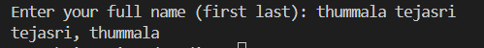
EXPLANATION:
The program takes the full name (first name and last name) as input.
The split() function separates the name into two parts:
- First name
- Last name
These parts are stored in separate variables.
The program rearranges the name into "Last, First" format.
The formatted name is printed as output.
Task 4: Comparative Analysis – Zero-Shot vs Few-Shot
# Generate code for taking user input full name and print format first,last examples like "John Smith" → "Smith, John" and "Anita Rao" → "Rao, Anita"
# Taking user input for full name
full_name = input("Enter your full name (first last): ")
# Splitting the full name into first and last names
first_name, last_name = full_name.split()
# Formatting and printing the name in "Last, First" format
formatted_name = f"{last_name}, {first_name}"
print(formatted_name)
# Example usage:
# Input: John Smith → Output: Smith, John
# Input: Anita Rao → Output: Rao, Anita
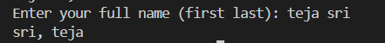
Explanation:
- This part works the same as Task 3.
- It takes the full name as input.
- Splits it into first and last name.
- Displays it in "Last, First" format.
# Generate code for user input string and count the number of vowels in it
# Taking user input for a string
#user_input = input("Enter a string: ")
# Defining a function to count vowels in the input string
#def count_vowels(input_string):
# vowels = "aeiouAEIOU"
#for char in input_string:
#if char in vowels:

# count += 1
#return count
# Counting vowels in the user input string
#vowel_count = count_vowels(user_input)
# Printing the number of vowels found
#print(f"Number of vowels in the input string: {vowel_count}")
# Taking user input for a string
user_input = input("Enter a string: ")
# Defining a function to count vowels in the input string
def count_vowels(input_string):
vowels = "aeiouAEIOU"
count = 0
for char in input_string:
if char in vowels:
count += 1
return count
# Counting vowels in the user input string
vowel_count = count_vowels(user_input)
# Printing the number of vowels found
print(f"Number of vowels in the input string: {vowel_count}")
# Example usage:
# Input: apple → Output: 2
# Input: Orange → Output: 3
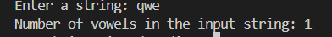
Task 5: Few-Shot Prompting – File Handling
#Generate code for function that reads a text file and returns the number of lines in the file.
def count_lines(filename):
with open(filename, 'r') as file:
return sum(1 for line in file)
# Example usage:
# Assuming 'example.txt' is a text file in the same directory
line_count = count_lines('example.txt')
print(f"Number of lines in the file: {line_count}")
# Example usage:
# If 'example.txt' contains 5 lines → Output: 5
Explanation:
- The program defines a function count_lines() that takes a file name as input.
- It opens the file in read mode ('r').
- The with statement ensures the file is properly closed after reading.
- The sum(1 for line in file) statement counts each line in the file.
- The total number of lines is returned.
- The result is printed to the user.

